|  |
| --- |
| **\* FOR EACH AUDIT THE BELOW SECTIONS MUST BE COMPLETED CLEARLY, ACCURATELY AND IN FULL.** |
| **BSCI Member Name (Mandatory) :**  **BSCI成员名称(必填) :** |
| **BSCI Member Code (If Available) :**  **BSCI成员编号 (选填) :**  The above number is a specific number allocated to BSCI Members. This number will allow BV to upload the report to the BSCI database even if the BSCI retailer has not added your factory to the database. 以上号码是分配给BSCI会员的特定号码。 即使BSCI成员尚未将您的工厂添加到平台的数据库，此编号也允许BV将报告上载到BSCI平台。 |
| **Product being Manufactured制造的产品 : Food 食品类**  **Non-Food非食品类** |
| **Service Type Requested 申请的审核类型 :**  **NOTE:** Starting from Jan 14, 2017, BSCI audits are defaulted as Semi-Announced with minimum 4-Week Audit Window. Fully Announced Audit can initiated by BSCI Member only with Solid Reasons provided in BSCI Platform. Audit firm has no authorization to submit Fully Announced audit request. If you would like a Fully Announced audit, please contact your BSCI member to change.  自2017年1月14日起，BSCI的默认审核类型为半通知型，并且至少有4周的审核周期。 全面通知型审核可以由BSCI会员发起，并且需要提供具体理由。 审计公司则无权提交全面通知型审核申请。 如果您想要全面通知型审核，请联系您的BSCI会员进行更改。 |
| **Desired Audit Date or Audit Window (4 Weeks) Period : (Please Specify)**  **期望的审核日期或审核周期 ( 至少4周 ) : ( 请注明 )** |
| **Announced Full Audit全面通知型審核 :  Announced Follow-Up Audit 全面通知型跟进審核 :** |
| **Semi-Announced Full Audit 半通知型審核 :  Semi-Announced Follow-Up Audit半通知型跟进審核 :** |
| **Unannounced Full Audit 突击审核 :  Unannounced Follow-Up Audit突击跟进审核:** |
| **Remark for Follow-Up Audit 跟进审核的备注 :**  If previous audit conducted by another audit firm (not Bureau Veritas), in order to be consistent with the scope of the BSCI program, the follow up audit Report will reflect the results of audit procedures limited to consideration of remediation of findings identified in a previous audit. Bureau Veritas does not take any liability for any issues or conditions of the previous audit. 如果之前的审核是由另一家审计公司（不是必维国际检验集团）进行的，为了与BSCI的审核范围保持一致，跟进审核对的报告将反映该次审核程序的结果，仅限于针对前次审核所发现的问题点的改善措施的执行。必维国际检验集团对前次审核的任何问题不承担任何责任。  Please note the final audit report will include a similar disclaimer as stated above. When this booking form submit to Bureau Veritas, it is a demonstration that you have accepted all terms stated above. 请注意，最终审核报告将包括类似如上所述的免责声明。 当此预订表格提交给必维国际检验集团时，表明您已接受上述所有条款。 |
| **Report Upload to BSCI Database 关于报告上传 :**  BV will upload the report within 5 working days of the audit to the BSCI database but only the following conditions fulfil. The BSCI retailer you supply to and named in above section has added your factory to the BSCI database and linked them to Bureau Veritas OR that you supply on this booking form the 6 character BSCI retailer membership number that will allow BV to add your factory to the BSCI database. BV将在审核后的5个工作日内将报告上传至BSCI平台，但仅满足以下条件。 您上述部分提供的BSCI成员已将您的工厂添加到BSCI平台并将其链接到数据库。 |

|  |
| --- |
| **Billing Information (Mandatory) 付款方资料 ( 必填 ) :** |
| **Company Name 公司名称 :** |
| **Company Address 公司地址 :** |
| **Contact Person 联络人 :** |
| **Phone 电话 / Fax 传真 :** |
| **E-mail 电子邮件 :** |
| **Remark: If factory (Audit Site) pays for the audit then above section could leave as empty.**  **备注 : 若将由工厂 ( 被审核方 ) 支付审核费用，则无需填写上述资料。** |

|  |  |  |  |  |  |
| --- | --- | --- | --- | --- | --- |
| **Factory Name (Audit Site) in English 工厂英文名称 :** | | | | | |
| **Factor Name (Audit Site) in Local Language工厂当地语言名称 :** | | | | | |
| **Address in English工厂英文地址 :** | | | | | |
|  | | | | | |
| **DBID Number of Factory (If available)** : | | | | | |
| **City 城市 :** | **Province of State 省份 :** | | | **Postal Code 邮政编码 :** | |
| **Address in Local Language 工厂当地语言地址 :** | | | | | |
| **Contact Person(s) 联系人 :** | | **Tel 电话 :** | | **Fax 传真 :** |  |
| **E-mail 电子邮件 :** | | | | | |
| **No. of Employees 参与生产的工人人数 :** | | | | | |
| **Production Process 生产流程 :** | | | **Product(s) Produced 产品 :** | | |
| **Primary Language(s) spoken by Management 管理层使用语言 :** | | | | | |
| **Primary Language(s) spoken by Employees参与生产工人使用语言 :** | | | | | |
| **Additional Notes 其他备注 :** | | | | | |
| **Remark: All the information required in this table is mandatory. 此表中所需的所有信息都是必填的。** | | | | | |

|  |  |  |
| --- | --- | --- |
| **PLEASE SEE PAGE 3 FOR TERMS AND CONDITIONS** | | |
| We apply for the above services and agree that all services will be carried out subject to the Bureau Veritas Consumer Products Services quotation and/or proposal received by our company as amended by the special terms and conditions stated on page 2 of this form. | | |
| ***Date:***  **日期** | ***Authorizing Name:***  **申请人** | ***Signature and Company Chop:***  **签名和盖章** |

|  |  |  |
| --- | --- | --- |
| BUREAU VERITAS CONSUMER PRODUCTS SERVICES – Corporate Social Responsibility ServicesTERMS & CONDITIONS | | |
| **Terms** | **Definition / Condition** | **Unit Price** |
| **Audit Site Access** | The ability of BV CPS auditors to conduct a credible audit depends on factory management’s cooperation and willingness to provide auditors access to employees for confidential interviewing, documentation for review (including payroll and attendance records), and access to all areas of the factory for visual observation. | n/a |
| Booking Lead Time | Request for audit should be made 30 calendar days prior to the desired audit date(s). | n/a |
| Scope | Audit findings are based on crosschecking data gathered from visual observation, confidential worker interviews, management interviews, and documentation review. | n/a |
| **Distribution of Worker Interview Information** | To effectively execute the audit confidential worker interviews are undertaken. It is BV's position to ensure that workers of factories will not be retaliated against due to comments or information obtained during the auditing process. In absence of objective evidence and to ensure the integrity of the audit process, BV reserves the right to non disclosure of information obtained from workers to the factory. Therefore, information obtained from interviews will be kept confidential and may not be included in the final audit report.  By accepting these terms and conditions you authorise BV to communicate where applicable worker interview information that may not be contained in the final report to the payee of the audit and/or the master client/retailer who owns the COC programme.  If the factory is the payee of the audit and the audit is NOT part of a master client/retailer programme then the worker interview information will NOT be communicated to any parties without the expressed permission of the factory. |  |
| **Man-day** | 8 hours spent on working and/or traveling with 1 hour break and in compliance with local labor law. | As per agreement with client |
| **Normal Working Days** | Mon – Fri (or in compliance with local labor law and customs) | n/a |
| **Working on Weekends** | If express service or other request requires that BV auditors work on weekends. | 20% surcharge (of total Man-day fees) |
| **Working on Holidays** | If express service or other request requires that BV auditors work on Public Holidays. | 30% surcharge (of total Man-day fees) |
| **Express Service** | Rush / ASAP booking within **7** days from desired audit date. | 50% surcharge (of total Man-day fees) |
| **Access Denied Charge** | Scheduled audit or assessment was not performed due to factory management not allowing BV staff to enter or conduct the audit or assessment for reason outside the control of BV staff. | Invoiced in full including Man-day fee(s) and all expenses incurred |
| **Late Cancellation Charge** | Cancellation of the audit less than 48 hours from scheduled audit day if auditors cannot be re-assigned to alternate audit. | Invoiced in full including Man-day fee(s) and all expenses incurred |
| **Extra Traveling Time Charge** | 1. If travel is required on the day before or the day after the audit  2. Waiting time day before or day after the audit date due to the lack of transport resources. | Up to 4 hours: additional 0.5 Man-day More than 4 hours: additional 1.0 Man-day |
| **Flight Charge** | Cost of air travel for standard coach | Invoiced at cost |
| **Traveling Expense** | Cost of travel expense other than air | Invoiced at cost or in accordance with pre-approved travel cost matrix |
| **Accommodation Expense** | 1. If travel is required on the day before or the day after the audit  2. If the audit requires 2 or more days to complete. | Invoiced at cost or in accordance with pre-approved travel cost matrix |
| **Liability** | Refer to CPS Conditions of Service. | n/a |
| CPS Conditions of Service | All services of Bureau Veritas Consumer Products Services Division are strictly offered, and can only be accepted, under the CPS Conditions of Service. Any party that requests said services, confirms said services, or makes any payment for said services does so agreeing automatically that: (a) it irrevocably accepts and agrees to the CPS Conditions of Service; (b) it waives all rights to change or challenge the CPS Conditions of Service; and (c) the CPS Conditions of Service are final and, unless expressly agreed otherwise by Bureau Veritas, any additional conditions sought to be imposed on any service or payment shall be invalid. The CPS Conditions of Service can be accessed through this link:  <http://www.bureauveritas.cn/BIMFSmtM/SD166_WI_BV_CPS_CONDITIONS_OF_SERVICE_REV03_11DEC15.pdf> | n/a |
| **Confidentiality** | BV CPS will maintain all information gathered during the audit process and any related reports confidential at all times. Information will only be shared with pre-approved parties. |  |
| **Payment Terms** | Prepayment is required for all invoice payers unless otherwise specified.  The credit terms of net 30 days from the invoice date may be offered to program clients based on the size of the program as per BV senior management's approval. Late payment might result in a change of payment conditions from credit to prepayment.  Invoices are payable whether the product/shipment is accepted, rejected, shipped, or unshipped. | n/a |
| All services will be performed according to Company’s generic protocols / standard operating procedures should the client not provide their own specific requirements. | | |
| When invoices for Company’s Services are issued to parties other than the Client (agent, vendor, factory, etc.), the other party must meet local credit requirement for the country where the invoice is issued, which may include partial prepayment or full prepayment. The Client will be notified of any unpaid invoices by their vendor/factory over 40 days from invoice date. The Company reserves the right to suspend services and/or change payment terms to full prepayment for Client’s account being overdue. All remittance charges, commission & bank charges, telegraph transfer, and any particular country tax charges shall be strictly borne by the invoice recipient/remittance party. | | |
| **\*\*TO ENFORCE OUR INTEGRITY POLICY, WE MAY SEND MYSTERY AUDITORS TO PERFORM SERVICES AND REPORT ANY CASES OF SUSPECTED BRIBERY TO THE LEGAL AUTHORITIES FOR FURTHER INVESTIGATION AND ACTION AS PER LOCAL LAW.”** | | |

|  |
| --- |
| **BSCI AUDIT APPICATION WORKFLOW 審核申请的大致流程** |

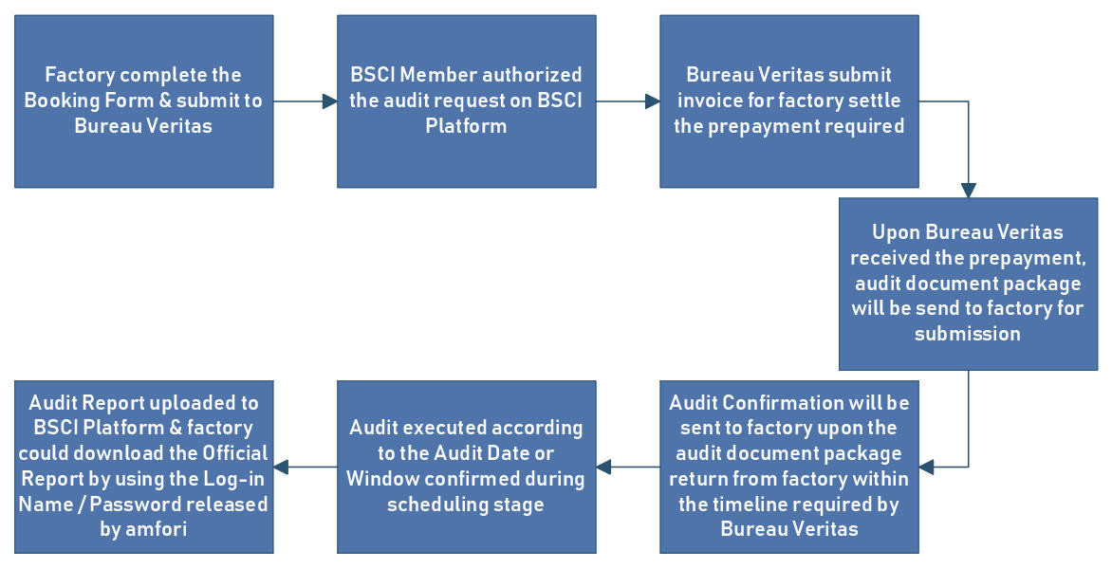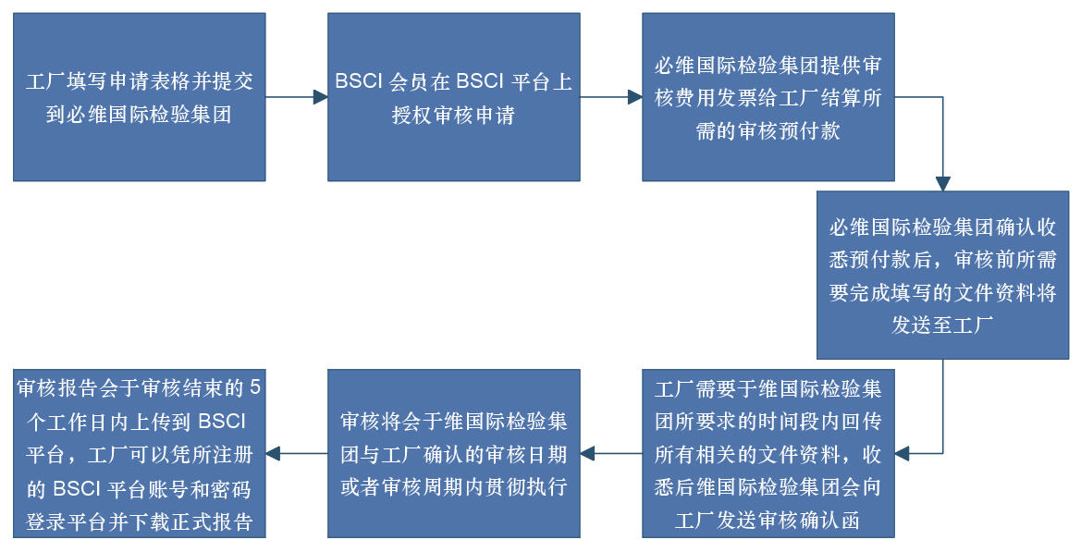

|  |
| --- |
| **BSCI INFORMATION LINKS 相关资讯链接 :**  **<http://www.amfori.org/members>**  **<http://www.amfori.org/content/amfori-bsci>**  **<http://www.amfori.org/content/bsci-code-conduct>** |